Installation Instructions for ArcGIS
Be sure you have filled out the request form to receive your license file. After submitting, please allow up to 24 hours for the email to arrive with your license file, it will be emailed to your Appstate email account. Please download and save this license file to your computer.
- Click the “Download Installer” link on our website
- Right click on the file that appears on the screen, choose “Download”
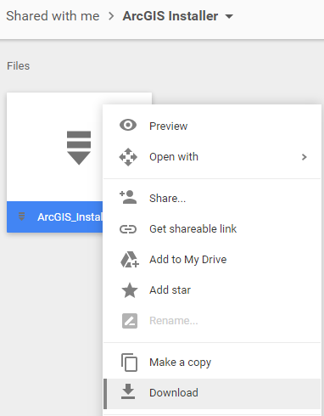

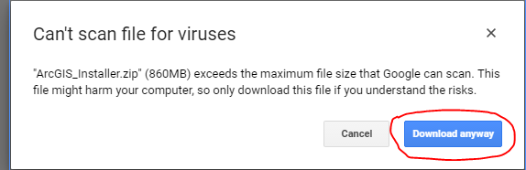
- It will prompt and ask if you would like to proceed with the download

- Navigate to your downloads folder. Find the folder labeled ArcGIS Installer, right click and choose “Extract All”
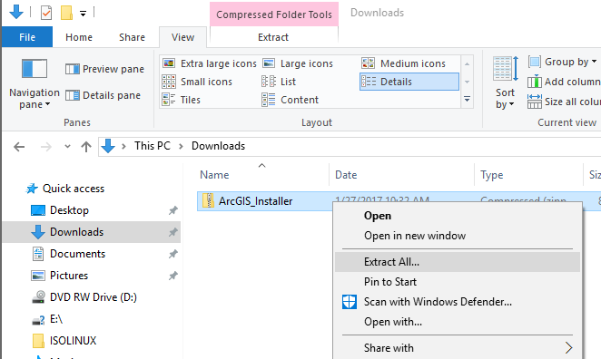

- Once Extracted, you will be able to double click on the install application to launch it

- Follow the prompts to install, it will walk you through the process

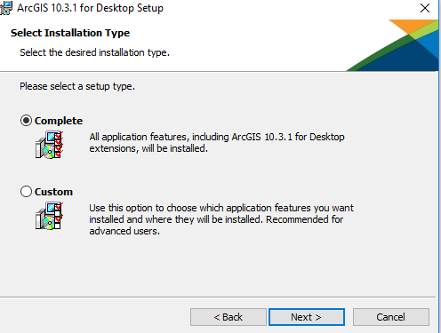
- For installation type, choose Complete

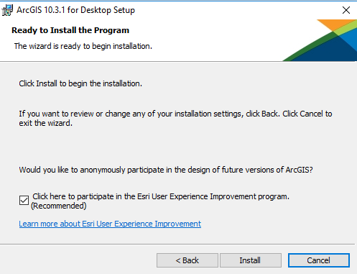
- Once you finish the prompts, click Install

- Once installed, ArcGIS will launch an authorization window.
- Check to be sure Advanced (ArcInfo) Single Use is checked at the top. Then click “Authorize Now”
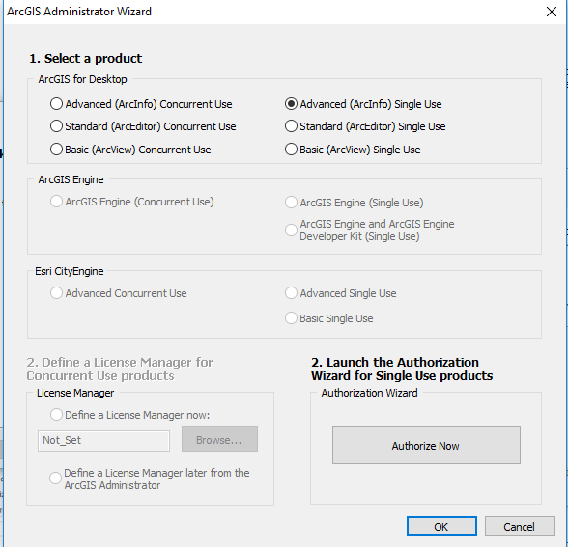

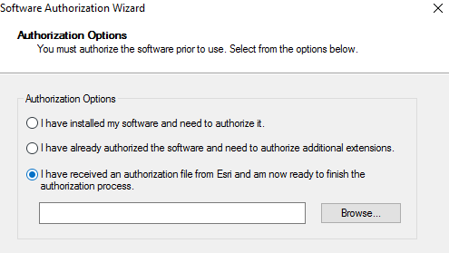
- In the next window, choose “I have an Authorization File from Esri”, Browse for the license file that you saved on your computer.

- After submitting the license file, ArcGIS will be licensed and ready to go. Please contact IT Support with any questions or concerns, 828-262-8324 option 2/ Anne Belk Hall.

